Kubernetes Task-10
- Setup eks cluster using eksctl
- setup eks cluster using console
- Setup HPA
- Setup cluster autoscale
- Setup cronjob and job
- Create secret and inject inside pod
- Check differen add-ons available on eks.
- Upgrade eks cluster

Task 1 — Create EKS Cluster using eksctl
Step 1: Check AWS CLI
On your AWS/EC2 admin machine:
aws --version
Check your credentials:
aws sts get-caller-identity
You should get your AWS account information.
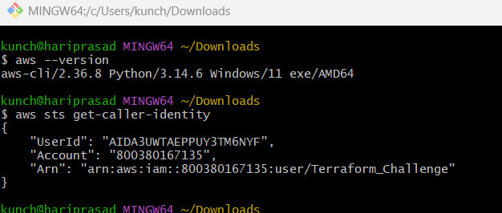

Step 2: Check eksctl
eksctl version
If it isn't installed, install it.
For Amazon Linux:
ARCH=amd64
PLATFORM=$(uname -s)_$ARCH

curl -sLO "https://github.com/eksctl-io/eksctl/releases/latest/download/eksctl_${PLATFORM}.tar.gz"

tar -xzf eksctl_${PLATFORM}.tar.gz -C /tmp

sudo mv /tmp/eksctl /usr/local/bin

eksctl version
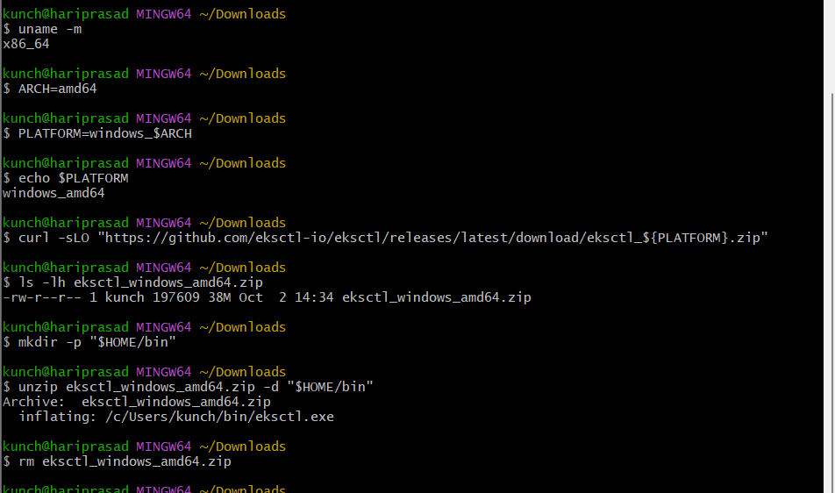

Step 3: Create EKS cluster
For example, use:
eksctl create cluster \
--name venu-eks-cluster \
--region ap-south-2 \
--nodegroup-name worker-nodes \
--node-type t3.medium \
--nodes 2 \
--nodes-min 2 \
--nodes-max 3 \
--managed
This creates approximately:
AWS Account
|
+-- EKS Cluster
|
+-- Control Plane
|
+-- Managed Node Group
|
+-- Worker Node 1
|
+-- Worker Node 2
Wait for the cluster creation to finish.
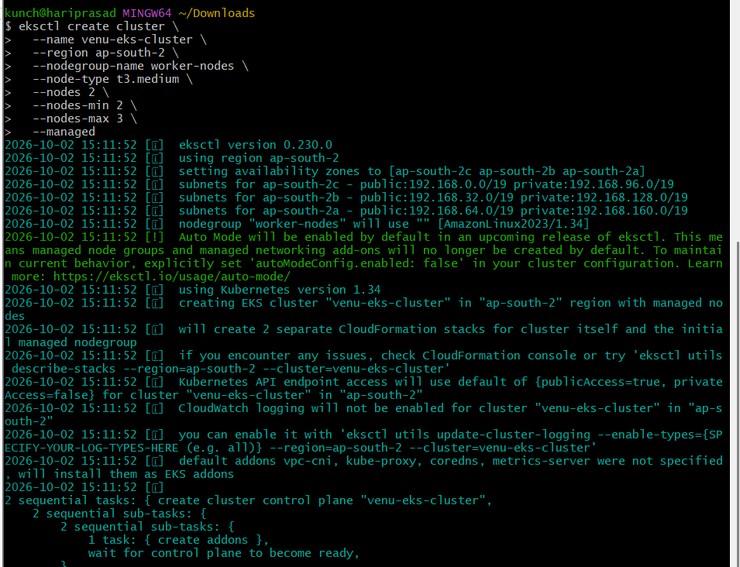
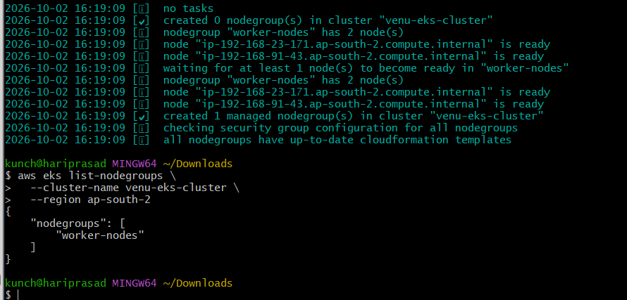

Step 4: Verify cluster
aws eks list-clusters --region ap-south-2
Then:
kubectl get nodes
Expected:
NAME STATUS ROLES
ip-xxx-xxx-xxx-xxx.ap-south-2.compute... Ready <none>
ip-xxx-xxx-xxx-xxx.ap-south-2.compute... Ready <none>
Check namespaces:
kubectl get ns
Check EKS system pods:
kubectl get pods -A
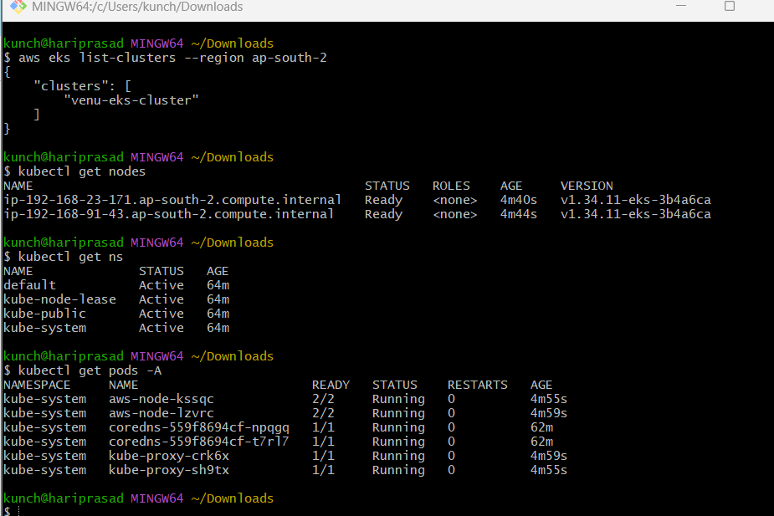

Step 5: Verify Kubernetes connection
kubectl cluster-info
And:
kubectl get nodes -o wide
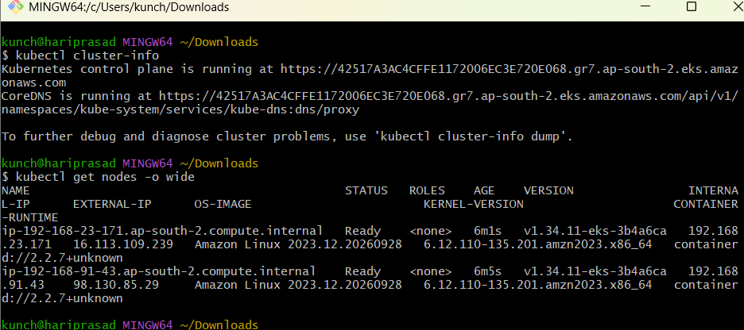

Task 2 — Create EKS Cluster using AWS Console
Go to:
AWS Management Console
Search:
EKS
Then:
Elastic Kubernetes Service → Clusters → Create cluster
Configure
Cluster name:
venu-eks-console
Kubernetes version:
Use a currently supported version shown by the console.
Cluster IAM role:
Create/select an EKS cluster role.
Networking:
- VPC
- Subnets
- Security groups
Then create the cluster.
After the control plane becomes:
ACTIVE
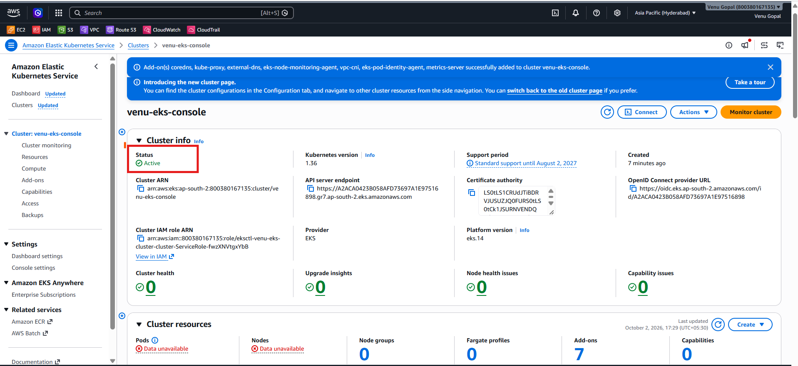
create a Managed Node Group.
Example:
Node group name: worker-nodes
Instance type: t3.medium
Desired size: 2
Minimum: 2
Maximum: 3
Then verify:
kubectl get nodes
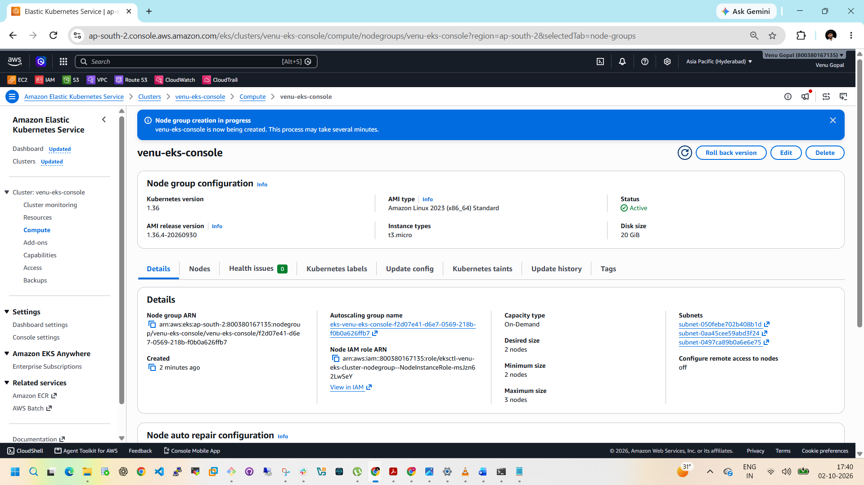
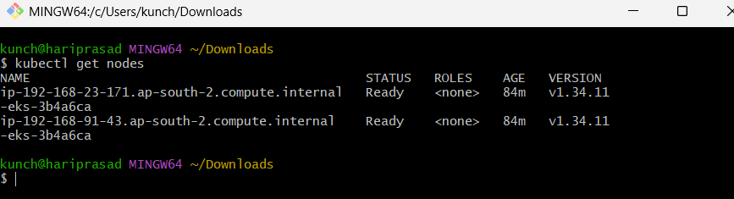

Task 3 — Setup HPA
This is important for interviews.
HPA means:
Horizontal Pod Autoscaler
It automatically increases/decreases Pod replicas based on metrics such as CPU utilization.
Flow:
CPU increases
|
v
+-----------+
| HPA |
+-----------+
|
v
Deployment
|
+--------+--------+
| | |
Pod Pod Pod
Step 1: Check Metrics Server
On EKS, check:
kubectl get deployment -n kube-system metrics-server
Also:
kubectl top nodes
and:
kubectl top pods
If kubectl top returns CPU/memory values, metrics are available.
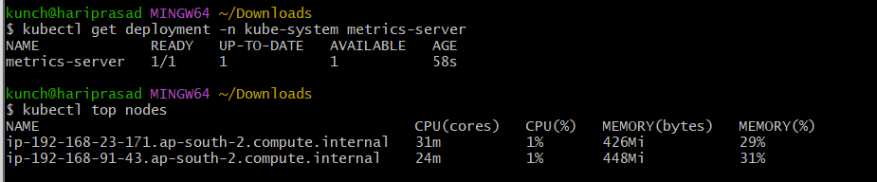

Step 2: Create deployment
Create:
vi hpa-demo.yaml
Use:
apiVersion: apps/v1
kind: Deployment
metadata:
name: hpa-demo
spec:
replicas: 1
selector:
matchLabels:
app: hpa-demo
template:
metadata:
labels:
app: hpa-demo
spec:
containers:
- name: nginx
image: nginx
resources:
requests:
cpu: 100m
limits:
cpu: 200m
ports:
- containerPort: 80
Apply:
kubectl apply -f hpa-demo.yaml
Check:
kubectl get pods
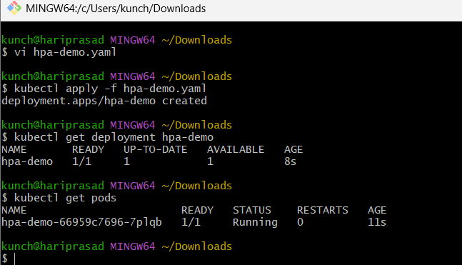

Step 3: Create HPA
kubectl autoscale deployment hpa-demo \
--cpu-percent=50 \
--min=1 \
--max=5
Check:
kubectl get hpa
You should see something like:
NAME REFERENCE TARGETS
hpa-demo Deployment/hpa-demo 0%/50%
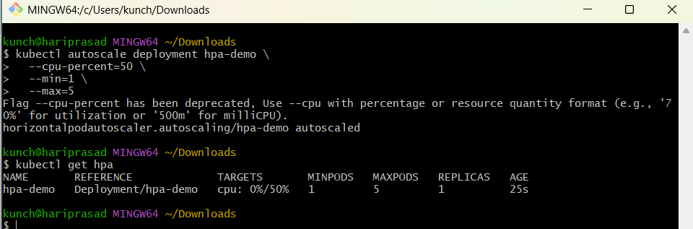

Step 4: Generate CPU load
We'll use a load-generator pod.
kubectl run load-generator \
--image=busybox \
-- /bin/sh -c "while true; do wget -q -O- http://hpa-demo; done"
But first expose the deployment:
kubectl expose deployment hpa-demo \
--port=80 \
--target-port=80
Then watch:
kubectl get hpa -w
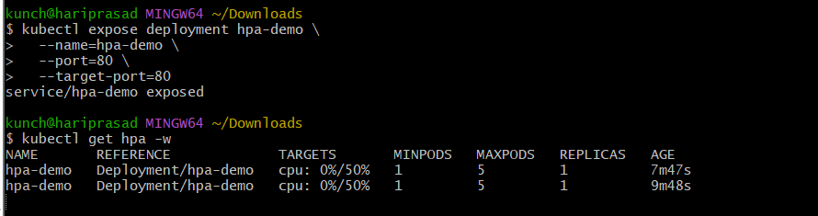
And:
kubectl get pods -w
You should eventually see replicas increase.
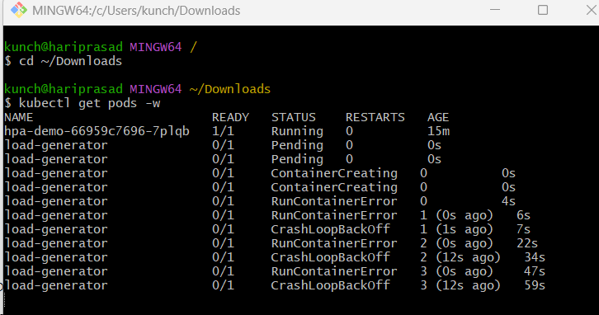
Interview explanation
HPA automatically adjusts the number of Pods based on resource utilization or other supported metrics. It scales the workload horizontally, not the EC2 worker nodes.

Task 4 — Setup Cluster Autoscaler
What we're going to build
EKS
|
Deployment/Pods
|
HPA scales Pods
|
v
Pod cannot be scheduled
|
v
Cluster Autoscaler
|
v
AWS Auto Scaling Group
|
v
EC2 Node added
The important distinction:
HPA
→ increases/decreases PODS

Cluster Autoscaler
→ increases/decreases NODES

Step 1 — Confirm your cluster
Run:
kubectl config current-context
You want:
arn:aws:eks:ap-south-2:800380167135:cluster/venu-eks-cluster
Then:
kubectl get nodes
You should have your two Ready nodes.
Also check:
aws eks list-nodegroups \
--cluster-name venu-eks-cluster \
--region ap-south-2
Expected:
worker-nodes
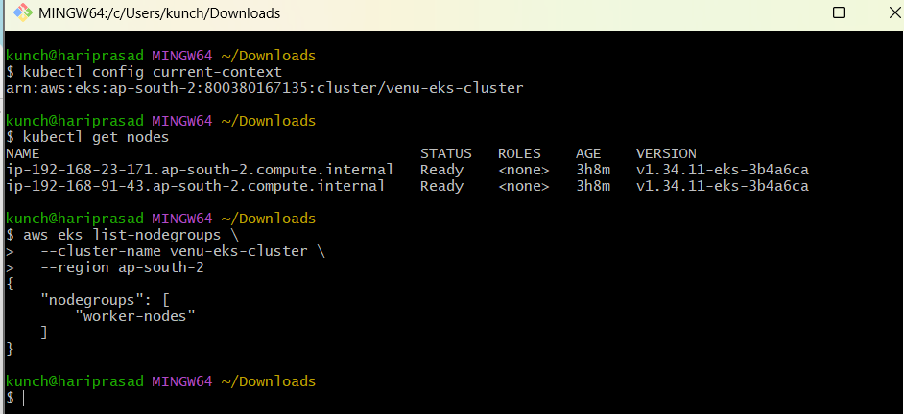

Step 2 — Find the Auto Scaling Group
This is important.
Your managed node group is backed by an AWS Auto Scaling Group (ASG). Cluster Autoscaler needs to discover that ASG.
Run:
aws eks describe-nodegroup \
--cluster-name venu-eks-cluster \
--nodegroup-name worker-nodes \
--region ap-south-2 \
--query "nodegroup.resources.autoScalingGroups"
You should get something like:
[
{
"name": "eks-venu-eks-cluster-worker-nodes-xxxxxxxx"
}
]
Don't guess the ASG name. Copy the actual name returned by AWS.
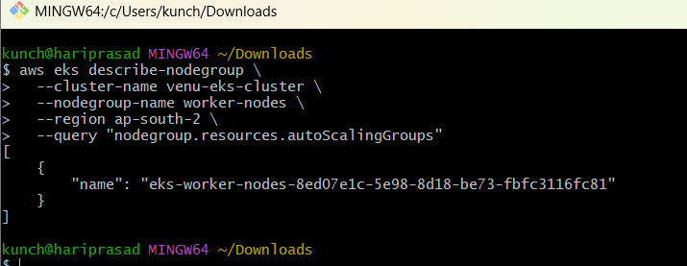

Step 3 — Check the ASG tags
Run:
aws autoscaling describe-auto-scaling-groups \
--auto-scaling-group-names YOUR_ASG_NAME \
--region ap-south-2 \
--query "AutoScalingGroups[0].Tags"
Replace:
YOUR_ASG_NAME
with the actual ASG name.
For Cluster Autoscaler auto-discovery, the ASG needs these tags:
k8s.io/cluster-autoscaler/enabled = true

k8s.io/cluster-autoscaler/venu-eks-cluster = owned
The Cluster Autoscaler uses these tags to discover the node group.
EKS managed node groups generally configure the ASG for Cluster Autoscaler, but we'll verify rather than assume.
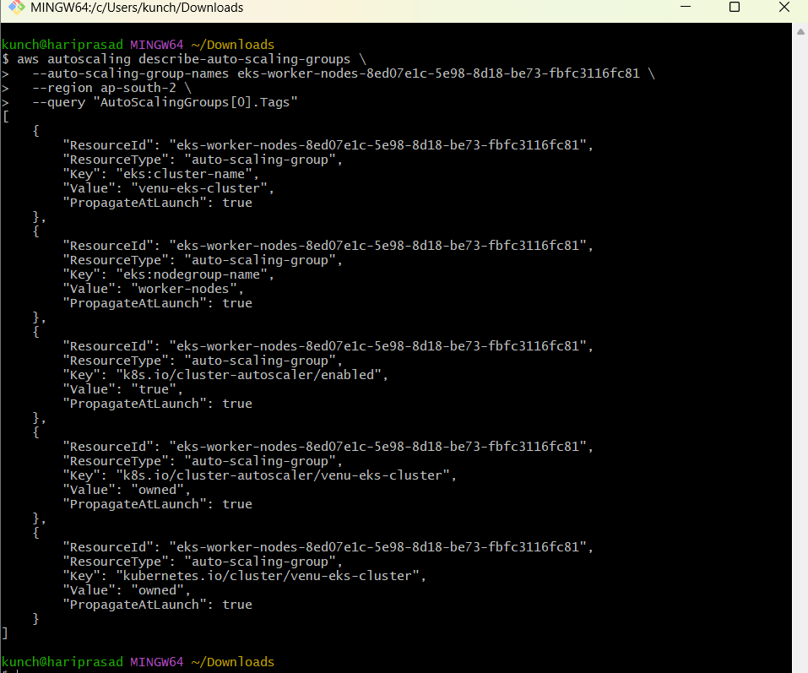

Step 4 — Check your node group's min/max
Run:
aws autoscaling describe-auto-scaling-groups \
--auto-scaling-group-names YOUR_ASG_NAME \
--region ap-south-2 \
--query "AutoScalingGroups[0].{Min:MinSize,Desired:DesiredCapacity,Max:MaxSize}"
We want:
Min = 1
Desired = 2
Max = 3
This is important because Cluster Autoscaler cannot scale beyond the ASG's maximum.
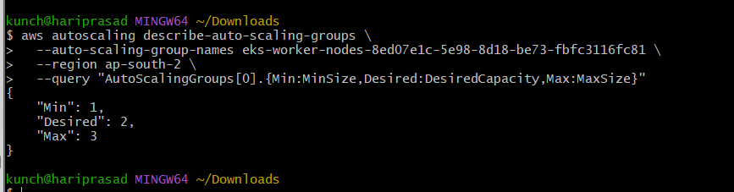

Step 5 — IAM permissions
This is the most important part.
Cluster Autoscaler needs permission to:
Describe ASG
Describe EC2
Set desired capacity
Terminate instances
The current Cluster Autoscaler AWS documentation provides the required AWS permissions and recommends auto-discovery using the ASG tags.
For your lab
We'll create a dedicated IAM role for the Cluster Autoscaler rather than giving broad permissions to your worker-node role.
Because you're using EKS, the clean approach is EKS Pod Identity or IRSA. For a first lab, we'll use the method that matches your cluster's available configuration rather than blindly applying an old tutorial.
So don't create the IAM policy yet.
First let's inspect your cluster's current OIDC/Pod Identity setup.
Run:
aws eks describe-cluster \
--name venu-eks-cluster \
--region ap-south-2 \
--query "cluster.identity.oidc.issuer" \
--output text
If it returns something like:
https://oidc.eks.ap-south-2.amazonaws.com/id/XXXXXXXX
we can use IRSA.
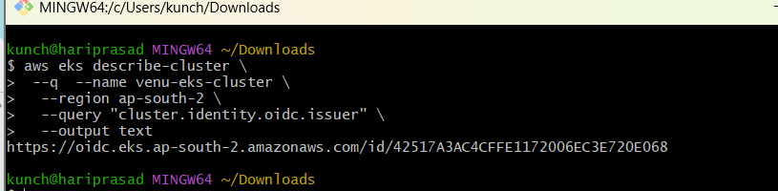

Step 6 — Install Cluster Autoscaler
We'll install the version that matches your Kubernetes version.
Your cluster currently has:
Kubernetes:
v1.34.11
We should not blindly use latest, because Cluster Autoscaler should match the Kubernetes minor version. The upstream project maintains version-specific releases.
So we'll use the 1.34.x Cluster Autoscaler image.
But before deploying it, we need to finish the IAM configuration.
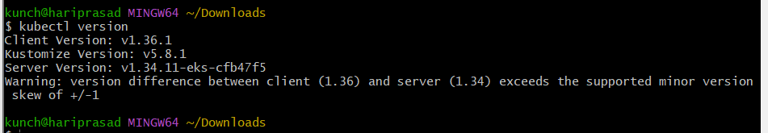

Step 7 — Configure Auto Discovery
The important arguments will look like:
--cloud-provider=aws

--node-group-auto-discovery=asg:tag=k8s.io/cluster-autoscaler/enabled,k8s.io/cluster-autoscaler/venu-eks-cluster

--balance-similar-node-groups

--skip-nodes-with-local-storage=false
The key part is:
k8s.io/cluster-autoscaler/venu-eks-cluster
because your cluster is named:
venu-eks-cluster
The upstream AWS provider documentation describes this auto-discovery mechanism.

Step 8 — Test scale-out
This is where the lab becomes interesting.
Initially:
Nodes
├── Node 1
└── Node 2
ASG:
Min = 1
Desired = 2
Max = 3
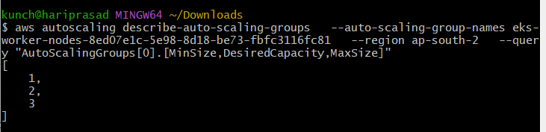
We'll create a workload that requests more CPU/memory than the two nodes can provide.
Some Pods will remain:
Pending
Then Cluster Autoscaler detects:
Pending Pods
↓
No suitable node
↓
Cluster Autoscaler
↓
ASG Desired: 2 → 3
↓
AWS launches EC2
↓
New Kubernetes Node
↓
Pod scheduled
Check:
kubectl get nodes -w
and in another terminal:
kubectl get pods -w

Step 9 — Test scale-in
After the workload finishes or is deleted:
3 Nodes
↓
Unused capacity
↓
Cluster Autoscaler
↓
ASG Desired: 3 → 2
↓
EC2 node removed
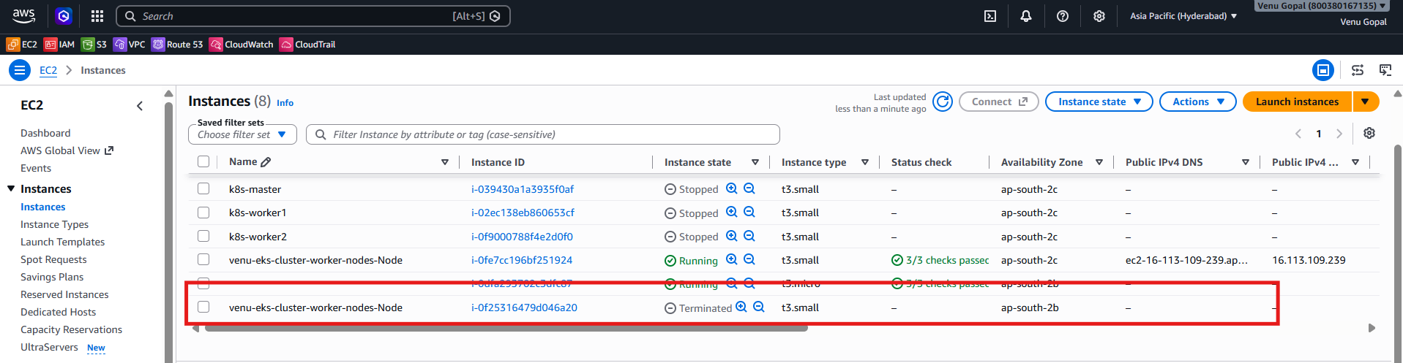
Check:
kubectl get nodes -w
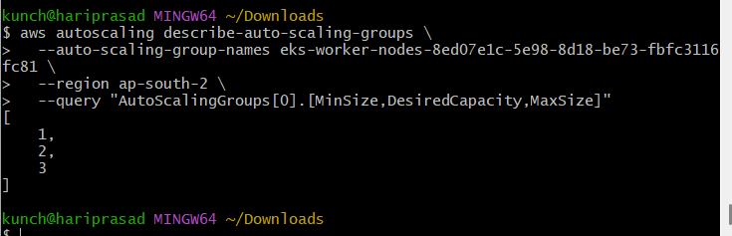
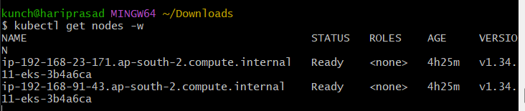

Task 5 — Job and CronJob
Job
A Job runs a task until successful completion.
Create:
vi job.yaml
apiVersion: batch/v1
kind: Job
metadata:
name: demo-job
spec:
template:
spec:
restartPolicy: Never
containers:
- name: demo
image: busybox
command:
- sh
- -c
- "echo Job started; sleep 10; echo Job completed"
Apply:
kubectl apply -f job.yaml
Check:
kubectl get jobs
kubectl get pods
Logs:
kubectl logs job/demo-job
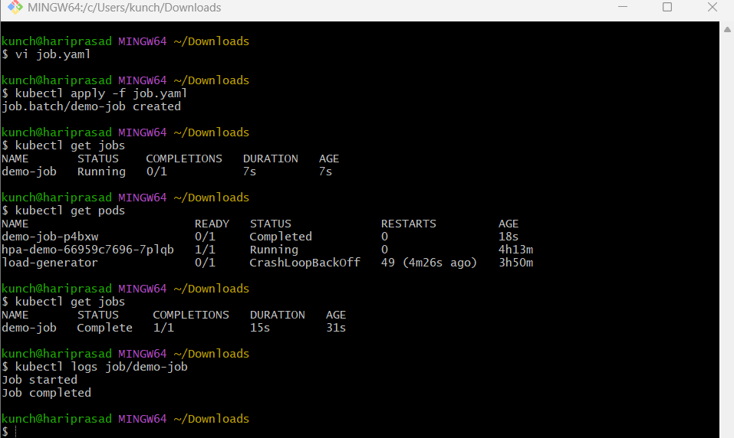

CronJob
CronJob runs a Job according to a schedule.
Create:
vi cronjob.yaml
apiVersion: batch/v1
kind: CronJob
metadata:
name: demo-cronjob
spec:
schedule: "*/2 * * * *"
jobTemplate:
spec:
template:
spec:
restartPolicy: Never
containers:
- name: demo
image: busybox
command:
- sh
- -c
- "date; echo CronJob executed"
Apply:
kubectl apply -f cronjob.yaml
Check:
kubectl get cronjob
Wait a few minutes:
kubectl get jobs
Check Pods:
kubectl get pods
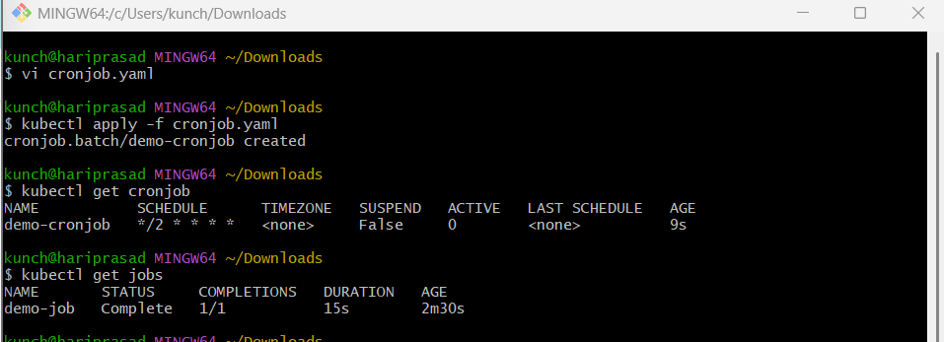
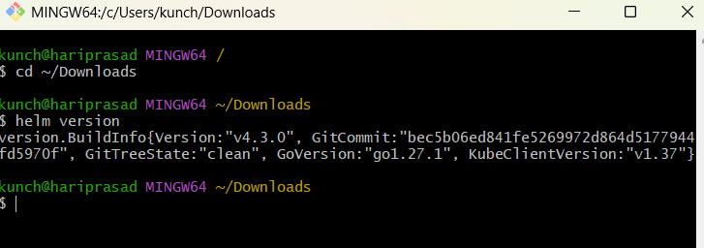

Task 6 — Create Secret and Inject into Pod
Create Secret:
kubectl create secret generic app-secret \
--from-literal=username=venu \
--from-literal=password='MyPassword123'
Check:
kubectl get secrets
Describe:
kubectl describe secret app-secret
Notice that Kubernetes doesn't show the actual secret values in describe.
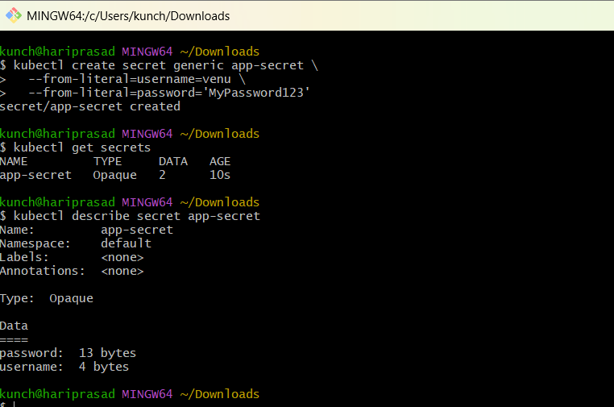

Inject as environment variables
Create:
vi secret-pod.yaml
apiVersion: v1
kind: Pod
metadata:
name: secret-demo
spec:
containers:
- name: nginx
image: nginx
env:
- name: APP_USERNAME
valueFrom:
secretKeyRef:
name: app-secret
key: username
- name: APP_PASSWORD
valueFrom:
secretKeyRef:
name: app-secret
key: password
Apply:
kubectl apply -f secret-pod.yaml
Check:
kubectl get pod secret-demo
Verify:
kubectl exec secret-demo -- env | grep APP_
Expected:
APP_USERNAME=venu
APP_PASSWORD=MyPassword123
Important interview point
A Kubernetes Secret is base64 encoded by default, not encrypted simply because it is a Secret. In production, you should consider encryption at rest, RBAC, and external secret-management solutions such as AWS Secrets Manager.
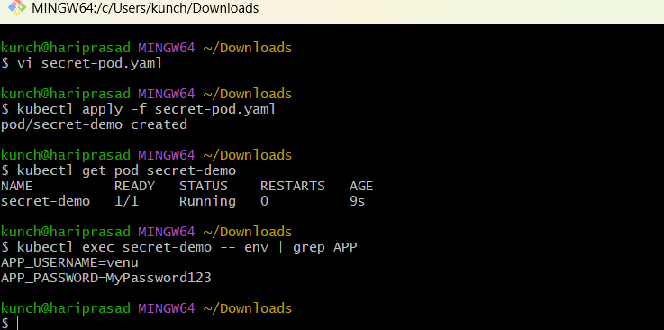

Task 7 — Check EKS Add-ons
First:
aws eks list-addons \
--cluster-name venu-eks-console \
--region ap-south-2
Check individual add-on:
aws eks describe-addon \
--cluster-name venu-eks-console \
--addon-name vpc-cni \
--region ap-south-2
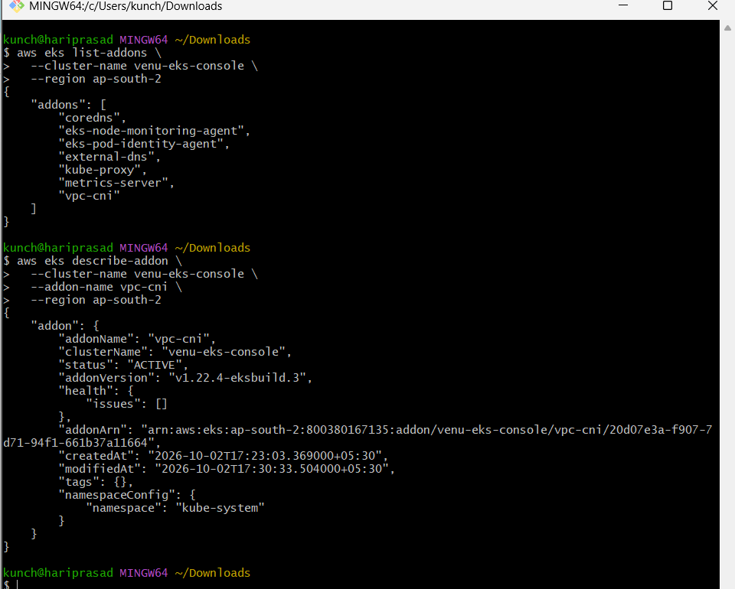
Common EKS add-ons include:
1. VPC CNI
aws-vpc-cni
Provides Kubernetes networking using AWS VPC networking.
2. CoreDNS
coredns
Provides DNS service inside the cluster.
3. kube-proxy
kube-proxy
Maintains networking rules for Kubernetes Services.
4. EBS CSI Driver
aws-ebs-csi-driver
Allows Pods to use AWS EBS volumes through Kubernetes PersistentVolumes.
You can check:
kubectl get pods -n kube-system
And:
kubectl get daemonsets -n kube-system
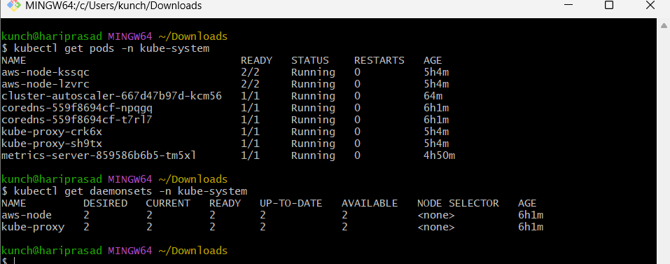

Task 8 — Upgrade EKS Cluster
Do this only after Tasks 1–7 are completed.
First check your current version:
aws eks describe-cluster \
--name venu-eks-console \
--region ap-south-2 \
--query 'cluster.version'
Check available versions:
aws eks describe-addon-versions \
--region ap-south-2
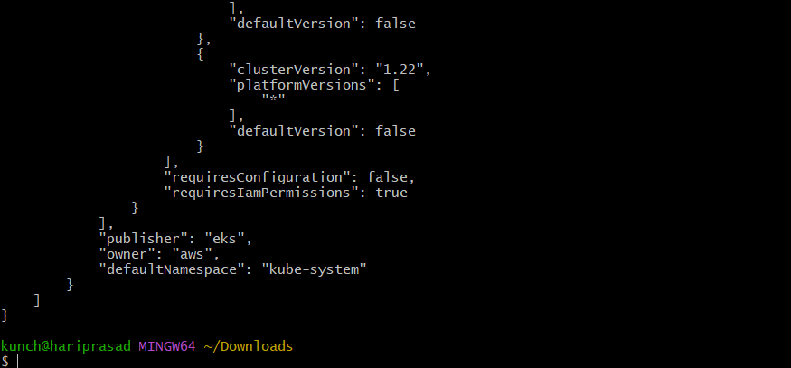
The exact upgrade target should be chosen from the versions currently offered by AWS for your cluster.
General upgrade flow:
Current EKS version
|
v
Check compatibility
|
v
Backup / review workloads
|
v
Upgrade EKS control plane
|
v
Upgrade add-ons
|
v
Upgrade node groups
|
v
Verify workloads
After upgrading:
kubectl version
kubectl get nodes
kubectl get pods -A
Check add-ons:
aws eks list-addons \
--cluster-name venu-eks-console \
--region ap-south-2
